Well Done for being green! | Well Done for being green!
Well Done for being green! | Well Done for being green!
Well Done for being green! | Well Done for being green!
Well Done for being green! | Well Done for being green!
Well Done for being green! | Well Done for being green!
Well Done for being green! | Well Done for being green!

Warning!  Remember to switch off next time! | Warning!  Remember to switch off next time!
Warning!  Remember to switch off next time! | Warning!  Remember to switch off next time!
Warning!  Remember to switch off next time! | Warning!  Remember to switch off next time!
Warning!  Remember to switch off next time! | Warning!  Remember to switch off next time!
Warning!  Remember to switch off next time! | Warning!  Remember to switch off next time!
Warning!  Remember to switch off next time! | Warning!  Remember to switch off next time!

You’ve been caught!  Remember to switch off next time! | You’ve been caught!  Remember to switch off next time!
You’ve been caught!  Remember to switch off next time! | You’ve been caught!  Remember to switch off next time!
You’ve been caught!  Remember to switch off next time! | You’ve been caught!  Remember to switch off next time!
You’ve been caught!  Remember to switch off next time! | You’ve been caught!  Remember to switch off next time!
You’ve been caught!  Remember to switch off next time! | You’ve been caught!  Remember to switch off next time!
You’ve been caught!  Remember to switch off next time! | You’ve been caught!  Remember to switch off next time!




The Green Classroom Chart

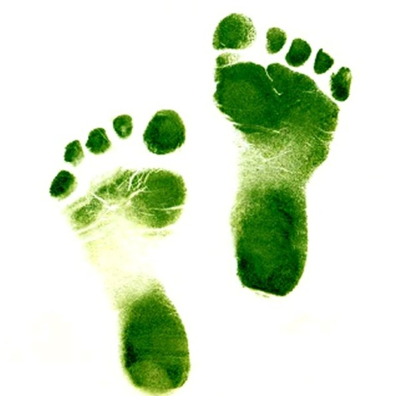
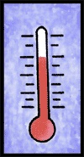
How many green cards does your classroom have?
18°C

